FDA and USDA Actions
- You are the local inspector at a USDA plant. The plant EST number is EST 5516. You have discovered the attached label in your plant. After consulting with the Labeling and Program Development Staff and based on a prior ruling from that team it has been decided that you will write an NR for this product. Please complete the attached NR form using the pictures below to describe the product and labeling issues. (25 points)
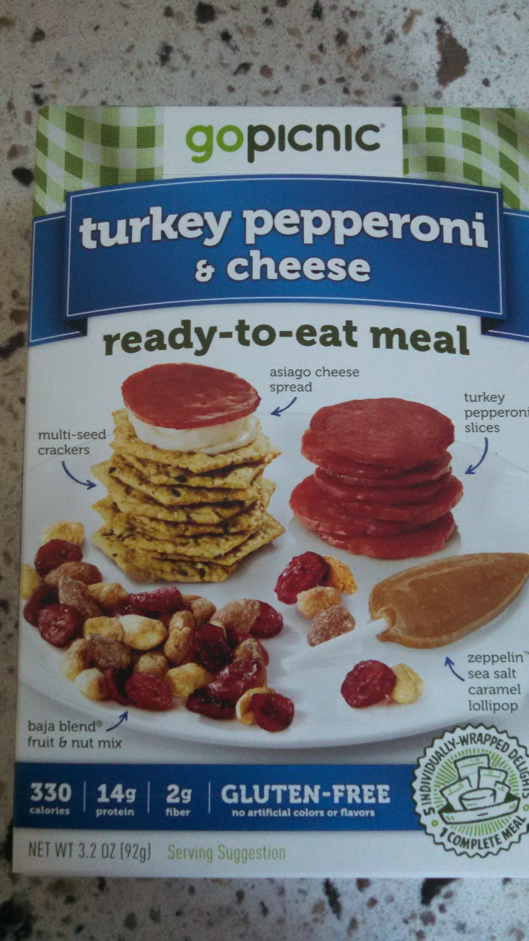
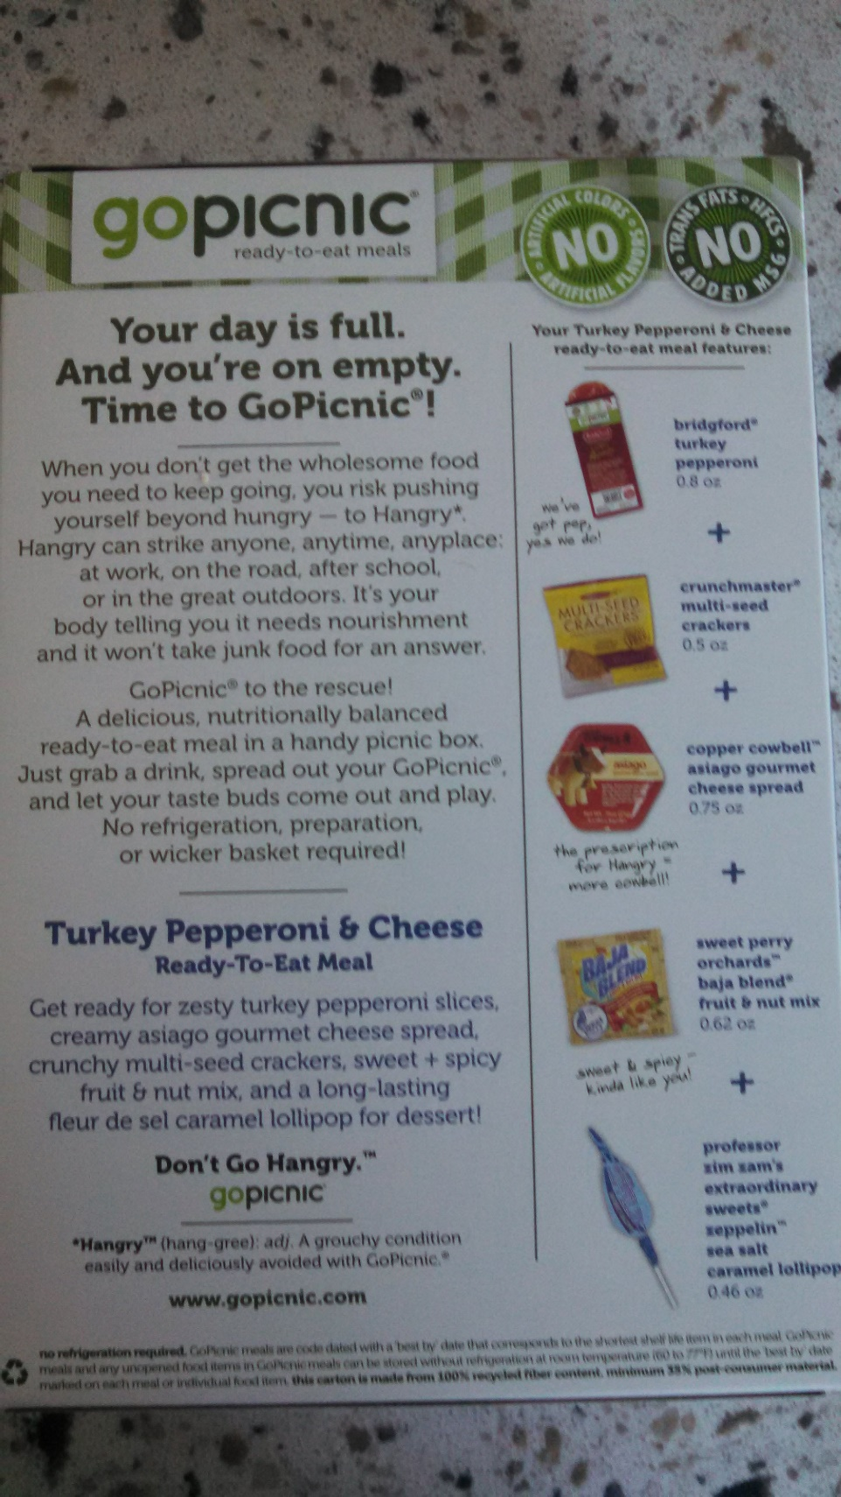
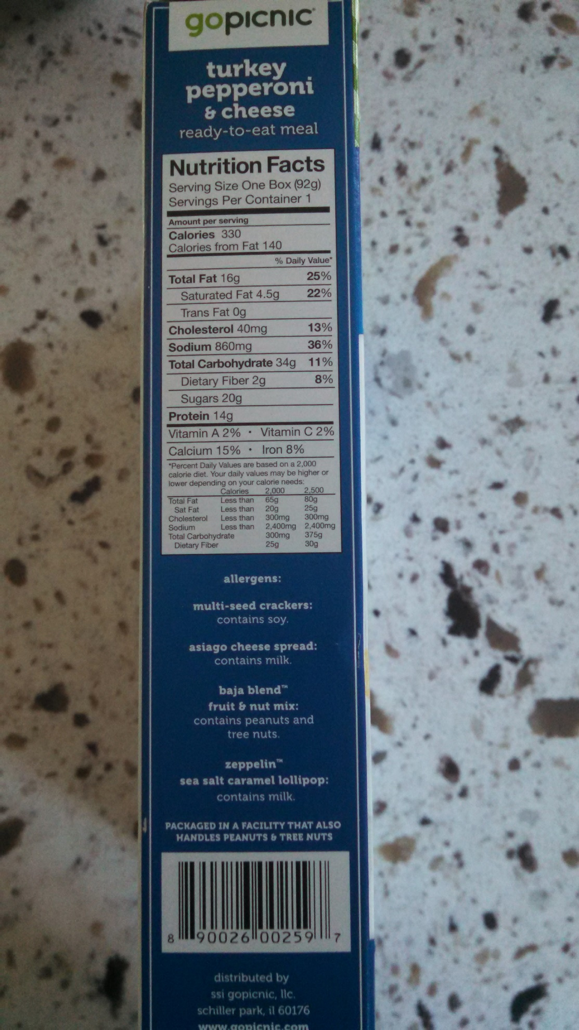
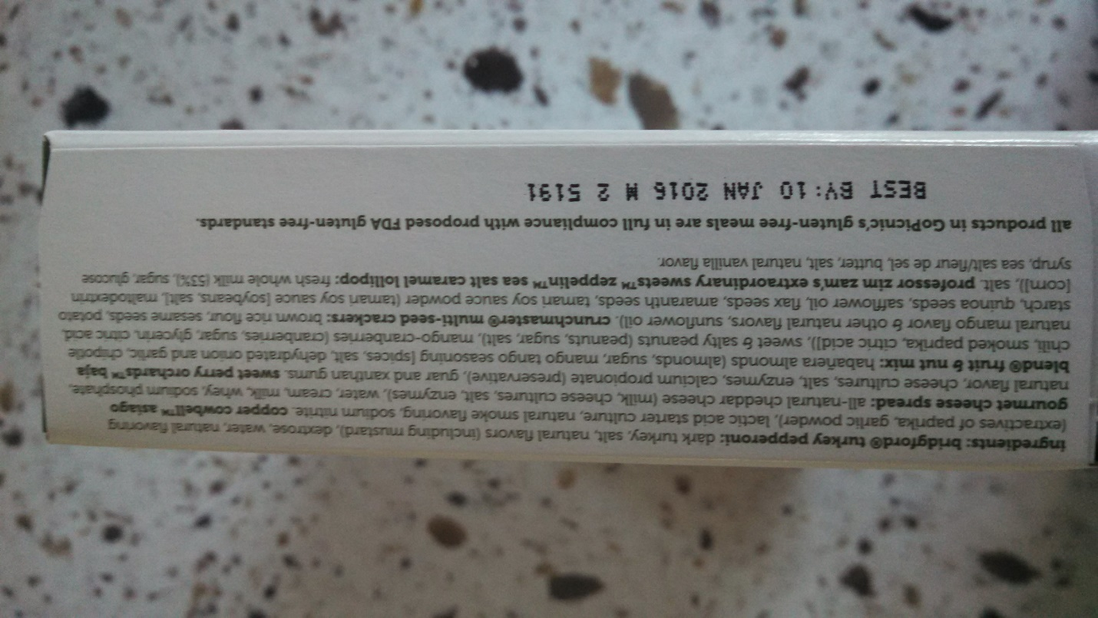
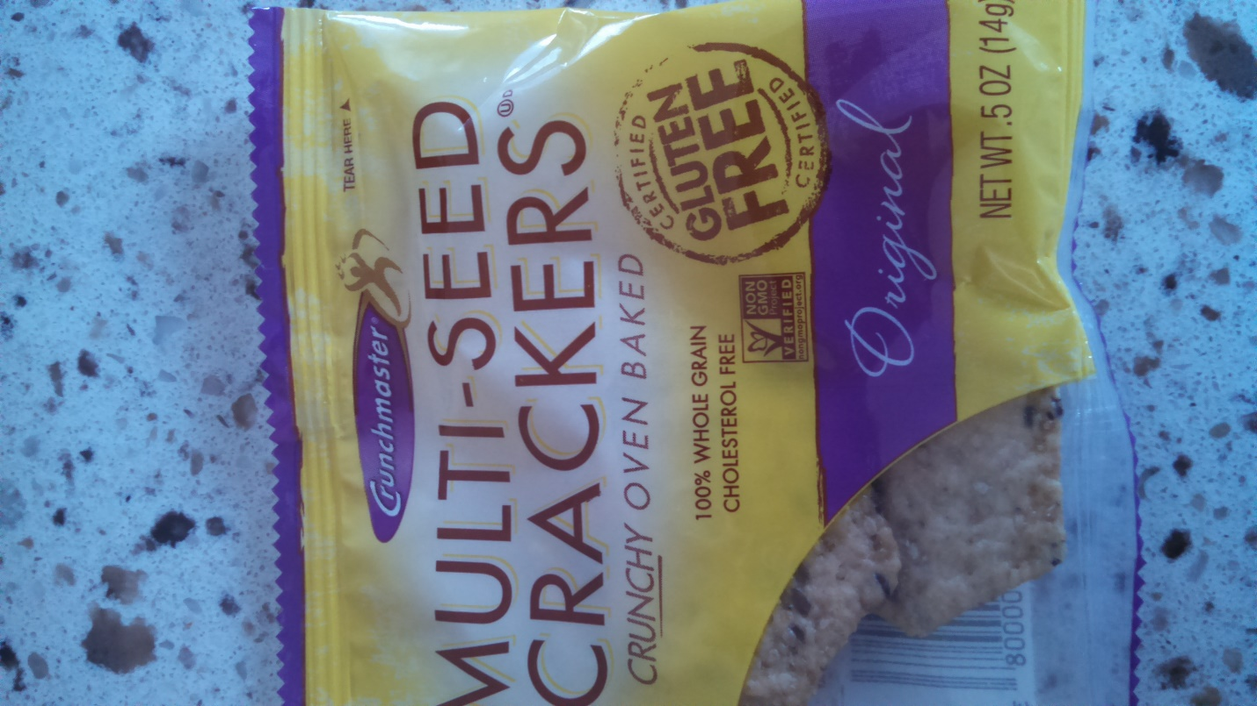
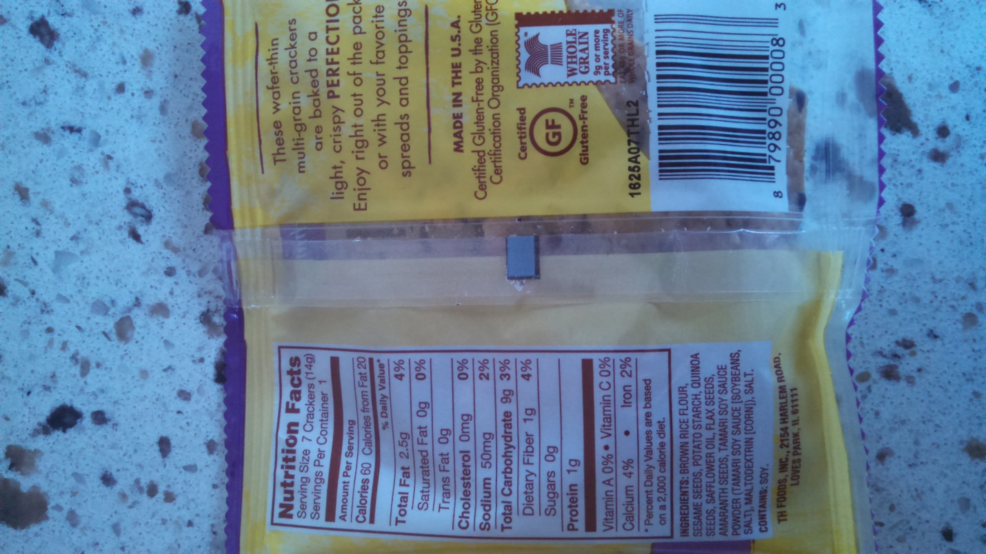
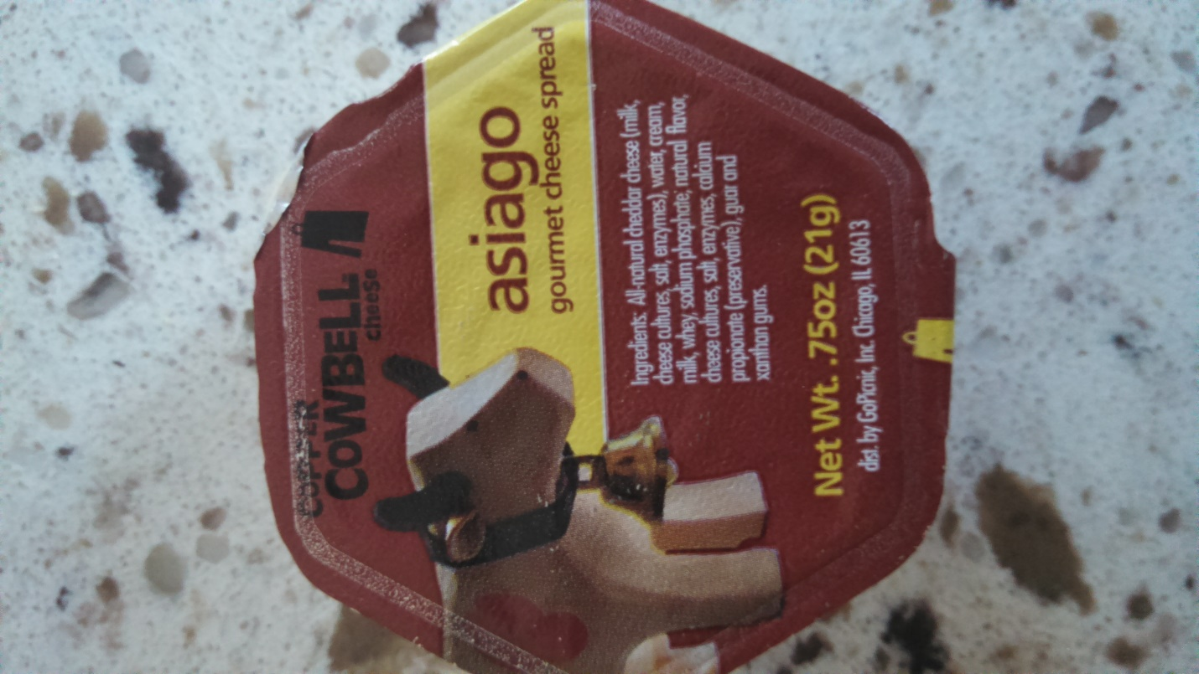
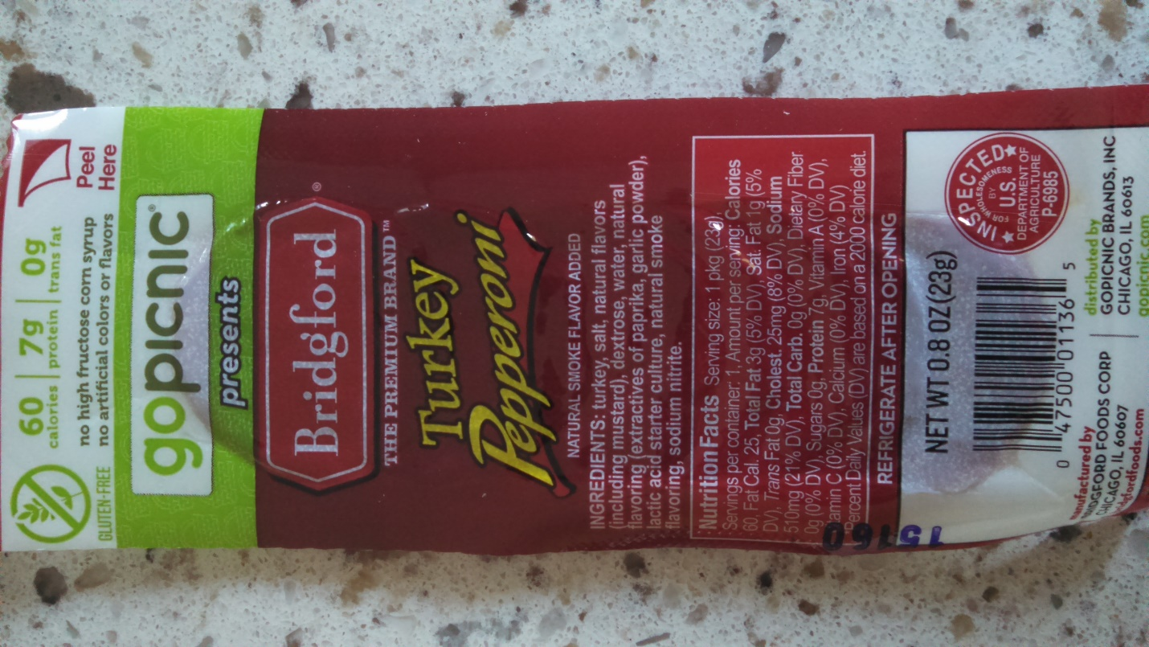
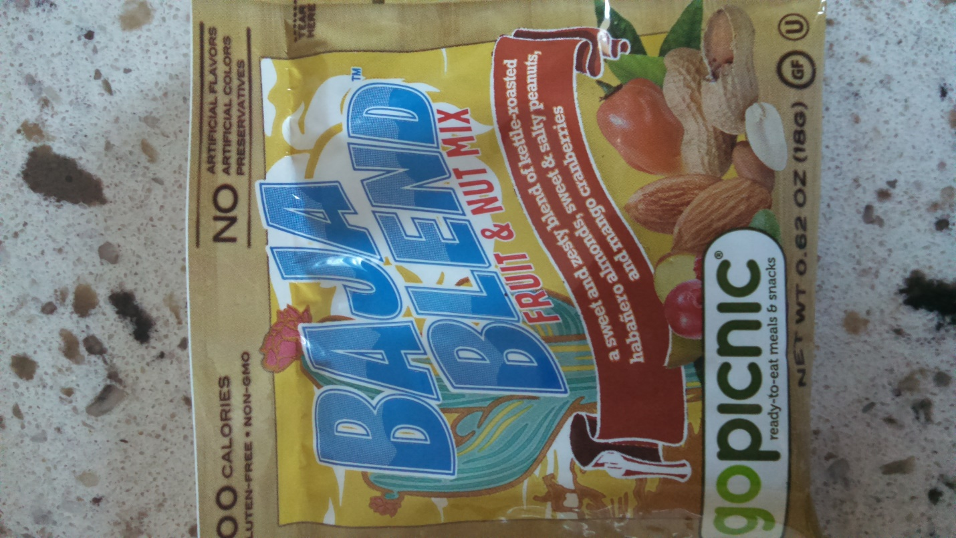
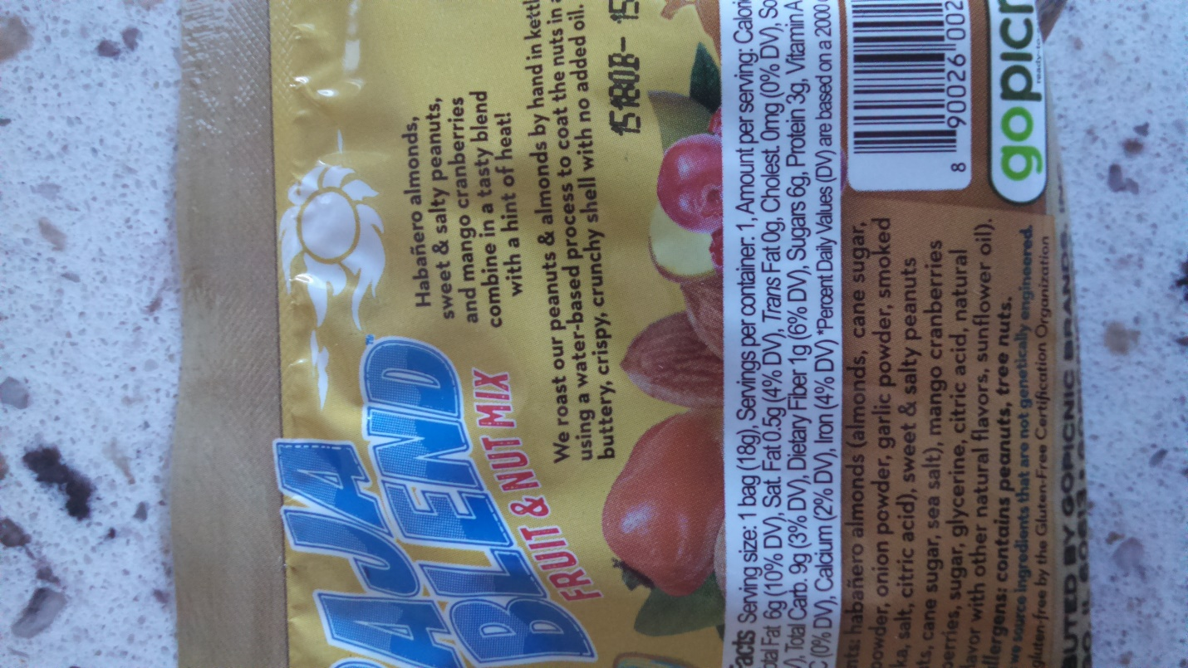
Its 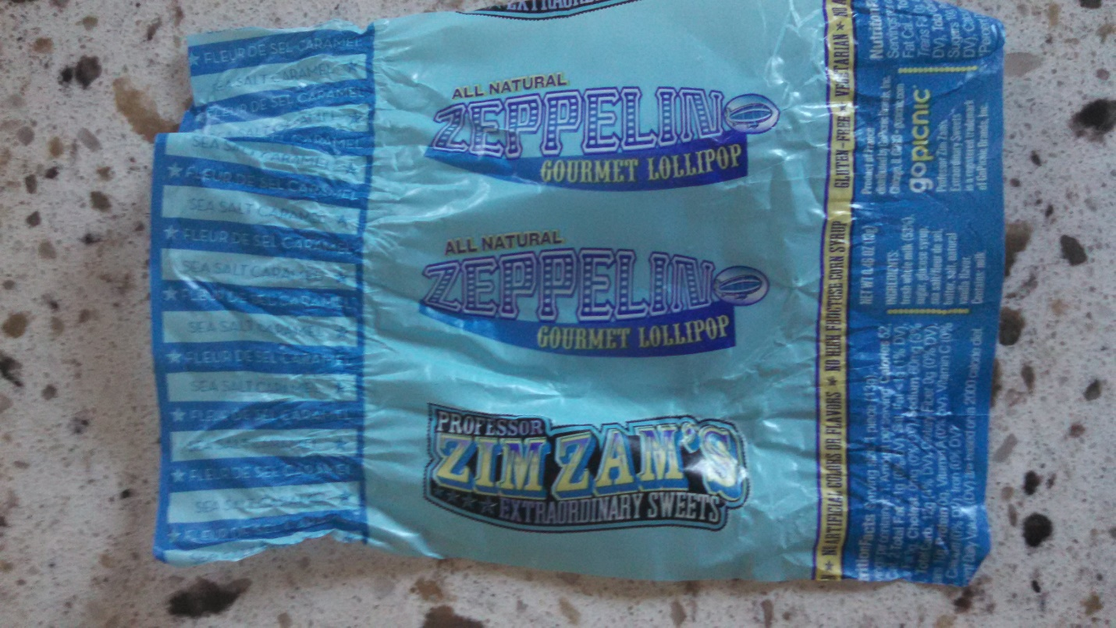

- The company you are working for has just received the attached FDA warning letter. Please write a response to the FDA for your company. (25 points)
https://web.archive.org/web/20150213034802/http://www.fda.gov/ICECI/EnforcementActions/WarningLetters/2014/ucm418768.htm

Public Health Service
Food and Drug Administration
Cincinnati District Office
Central Region
6751 Steger Drive
Cincinnati, OH 45237-3097
Telephone: (513) 679-2700
FAX: (513) 679-2775

Adam P. Mueller, President
Minerva Dairy, Inc.
430 Radloff Avenue
Minerva, Ohio 44657
October 15, 2014

RESPONSE TO WARNIGN LETTER: CIN-15-431214-02
Dear Mr. Teitell:

Our organization has received and carefully acknowledged the outcomes of the inspection exercise dated in the warning letter. Upon receiving the letter, the labeling department in conjunction with a multidisciplinary team held a crisis meeting to deliberate on the directions given in the letter.

We immediately rolled out strategies that would ensure a raft of well thought-out corrective actions in line with the regulations and legal provisions. We have outlined a time line of three weeks to ensure complete overhaul of our labeling practices to reflect all the policy and legal requirements. We are thankful for your office’s intervention and immediate action has been taken to ensure total compliance.

In summary, the following actions have been adopted;
- Rebranding “All Natural Ilios Greek Yogurt Butter” to the “Great Ilios Greek Yogurt Butter” to eradicate inconsistencies in use of “healthy” as outlined in 21 CFR 101.65(d)(2).
- We have upped the weight of milk fat in our Great Ilios Greek Yogurt Butter product to comply with branding requirements in section 403(i) (1) of the Act [21 U.S.C. § 343(i) (1)].
- We have included the usual names of all ingredients on out labels to conform to branding requirements in section 403(i) (2) of the Act [21 U.S.C. § 343(i) (2)].
- We have included exclusive declaration of dietary fiber and sugars in line with requirements in 21 CFR 101.9(c) (6) (i) and (ii).

We wish to retaliate our position that we shall continue to be a law-abiding manufacturing facility that observes all requirements outlined by the Act and the CFR regulations. Lastly, we shall underrate bi-annual audits to ensure our labelling practices are fully compliant to the prevailing regulations.

Yours Sincerely,
Adam P. Mueller, President
Minerva Dairy, Inc.

